Method: Blind Dado (with qualified tenon)

Face Frame (3/4 thick)
Stiles 2”
Bottom Rail 2”
Top Rail Base 2”
Top Rail Wall / Tall 3”
Return End Stile Base 3”
Return End Stile Wall 2”
Extended End Stile Base 3 ¾”
Extended End Stile Wall 2 ¾”

To modify Frame sizes:
Click Libraries
Select FACE FRAME
Click the Construction Button
Select the FACE Category

To modify Ret/Ext End Stiles
Click Libraries
Select FACE FRAME
Click the Construction Button
Select the ENDS Category

SCRIBE
Finished End Scribe – ¼”
Unfinished End Scribe – ¼”

To modify Scribe
Click Libraries
Select FACE FRAME
Click the Construction Button
Select the CASE Category

Material Templates

www.mozaiksoftware.com

Optimized for flat panel processing
This construction method is for Face Frame and Frameless construction with hidden dados. Bottoms & Tops dado into the ends, partitions dado into the Top & Bottom. Fixed Shelves dado into the verticals. All tenons are machined to a qualified thickness. This ensures a perfect fit (even if the material thickness varies slightly from sheet to sheet).
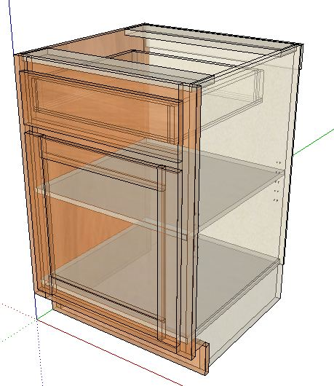
Part Operations.
Case Parts
Dado Depths.
Bottom / Top into End Panels ¼”
Fixed Shelves ¼”
Partitions into Bottom/Top ¼”
Back into End panels ¼”
Adjustable Shelves.
3/16” clearance
Face Frames
Butt Joint construction (Pocket Screws-recommended)
Machining Specifications.
Nested Based Router Setup.
Tool #1 3/8 compression spiral (Outline tool)
Tool #2 3/8 down shear bit (dados/pockets)
Tool #3 1/4 down shear bit (back dados)
Tool #4 1/2 down shear bit (3/4 dados/pockets)
Drills 5mm
(If no boring block, place a 5mm bit into Tool #5)

Machines with no Tool Changer.
Primary Tool 1/4 compression spiral.
(Adjustable shelf holes will be ¼”.)

Assembly Details.

Page 2 www.mozaiksoftware.com

